How to configure central Firewalls
1 Introduction 2
2 Prerequisites 2
3 Step-by-step plan 3

Introduction
This manual is intended as guide for configurating the central firewalls

Prerequisites
Filled in xls Template file
Privileged user for central firewalls (AD group: JDN_GSR_LOG_ON_ALL_JUNIPERs_F)
Network security manager (Juniper NSM)

Step-by-step plan
- Connect to the vpn concentrator firewall of Aalst.
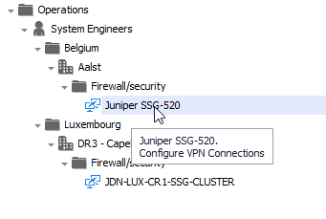
- Login with a priviledge user
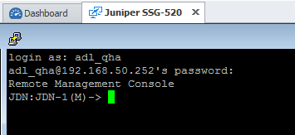
- Copy the commands generated for Aalst into the cli
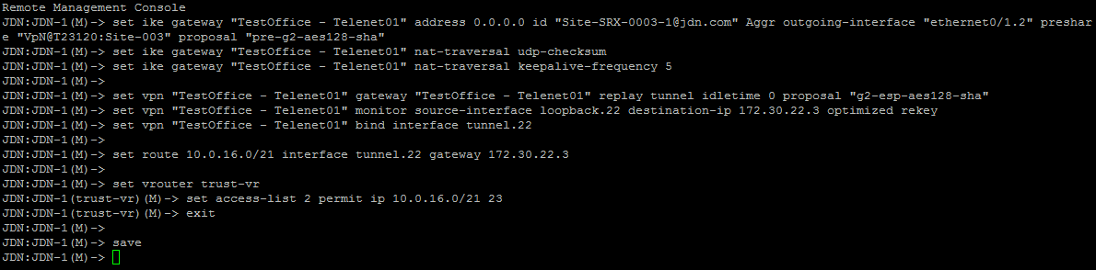
- Go to Network Security Manager (NSM) and import the firewall:
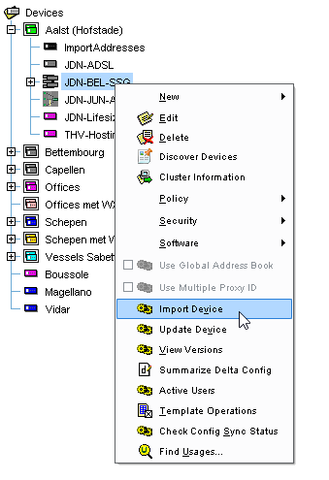
- Run the summarize Delta Config
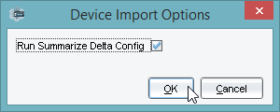
- Check If you are only importing your changes
Click on “Import Device”
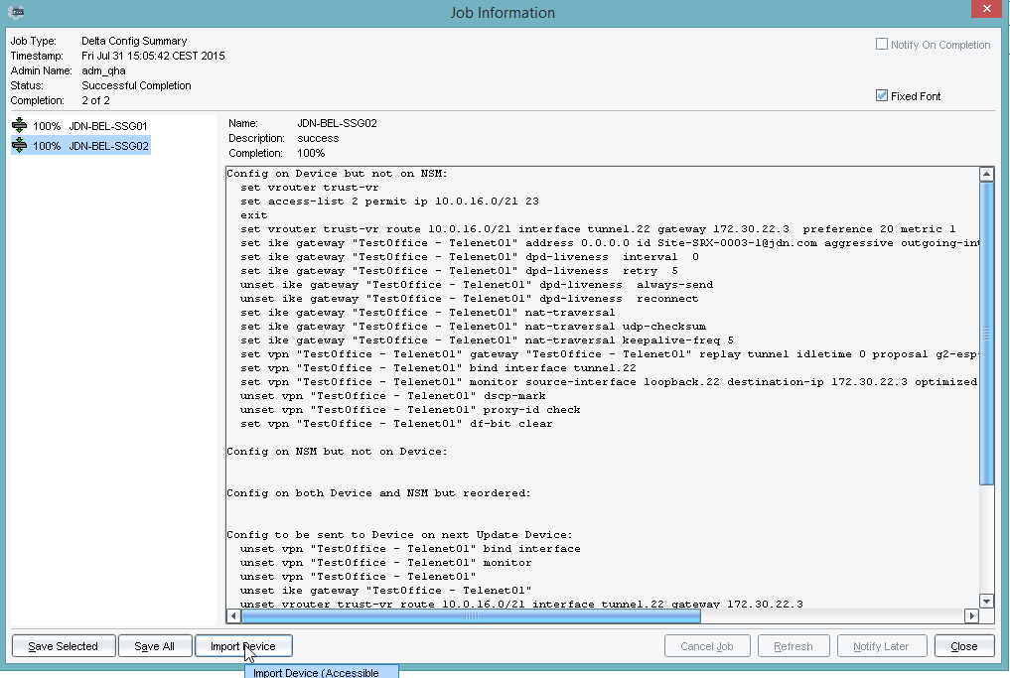
- Click “Yes”
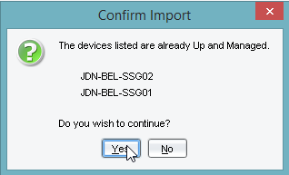
- Close the window
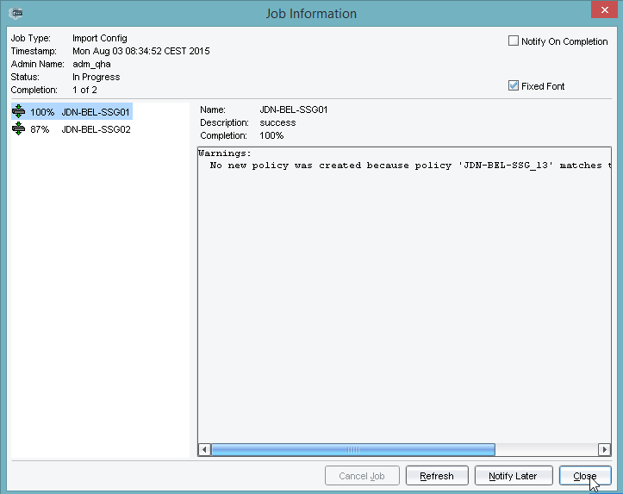
- Connect to the vpn concentrator of LUX
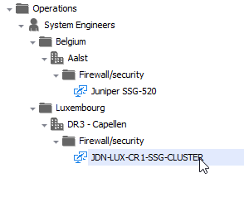
- Login with a priviledge user
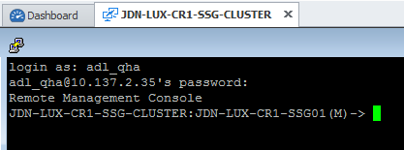
- Copy the commands generated for Lux into the cli
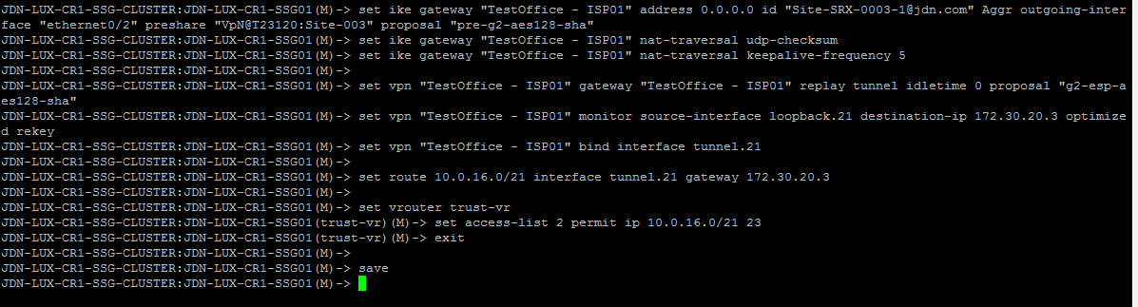
- Go to Network Security Manager (NSM) and import the firewall:
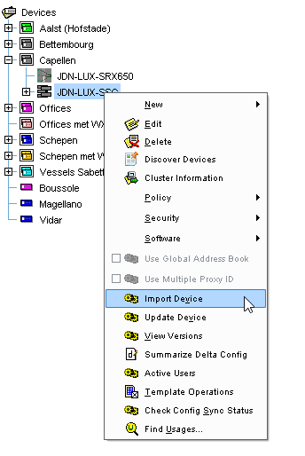
- Run the summarize Delta Config
- Check If you are only importing your changes
Click on “Import Device”
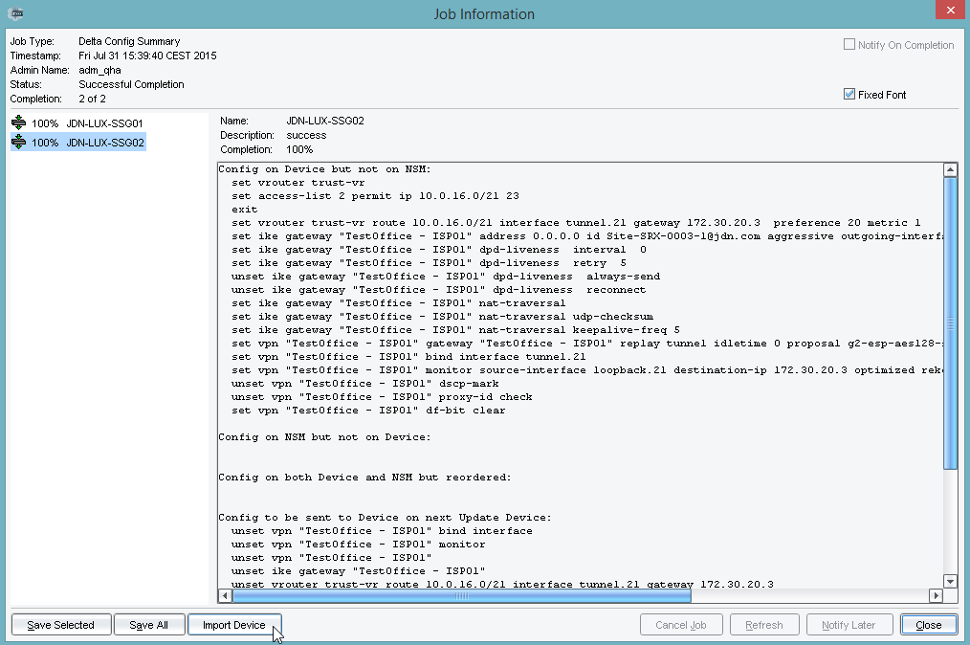
- Click “Yes”
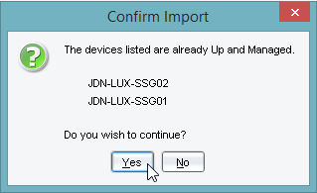
- Close the window
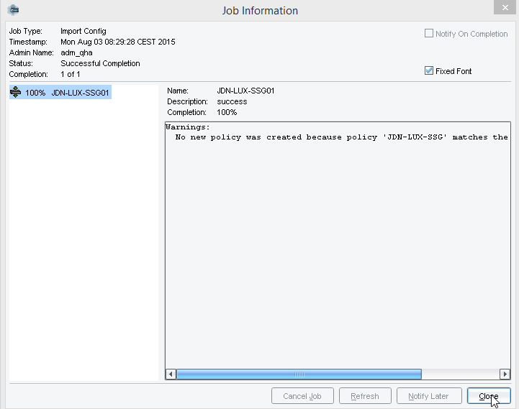
- Go to https://pulse.jandenul.com/admin and login
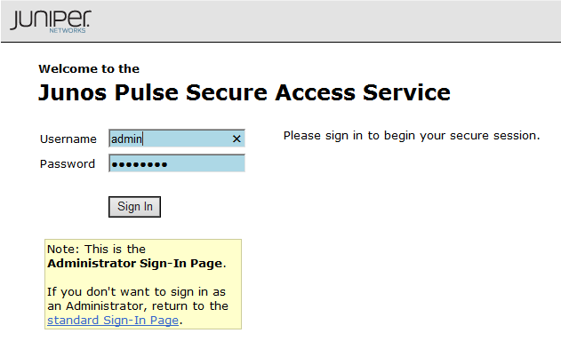
- Go to Users/Resource Profiles/Split-tunneling Networks
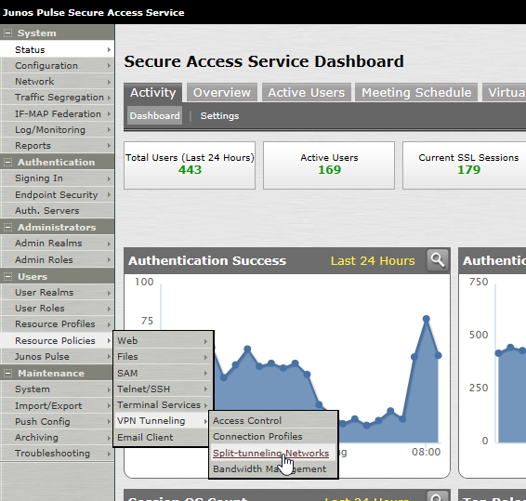
- Select the policie “Role PULSE Full access” and click “Update”
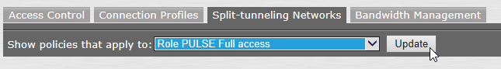
- Click on “NC full split tunnels”
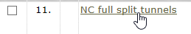
- Add the network range to the “Resources”
and “Save Changes”
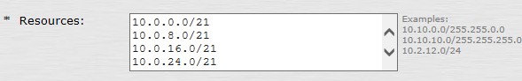
- Check if the changes are successfully commited
